OpenShift Containerization POC 2026 – POC Test Protocol
Number: | 022 | Test Date: | 11. Feb 2026
Test Owner: | Naga Krishna Sai Baruri
Comments: | Deploy Cluster with assisted way with keepalived.conf

Test Results
Test was Successful. | ☒
Test was successful with constraints. | ☐
Test failed | ☐

Test Objective (Evaluation Criteria / Requirements)
Deploy Cluster with assisted way with keepalived.conf, so that when the master node with holding the API VIP is down the other master node should takeover.

Expected Result
Deploy Cluster with assisted way with keepalived.conf, so that when the master node with holding the API VIP is down the other master node should takeover.

Test Results
- Login into https://console.redhat.com/ with our credentials
- On the left pane, click on cluster management and hit cluster.
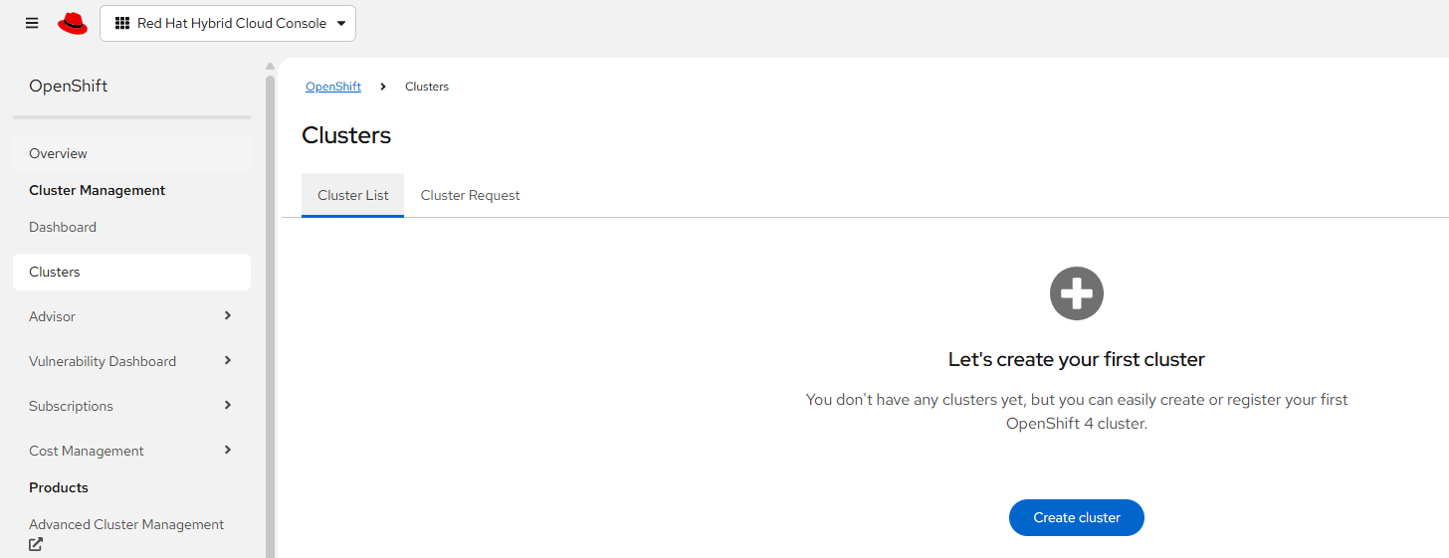
- click on create cluster and click on Datacenter and select Bare Metal (x86_64).
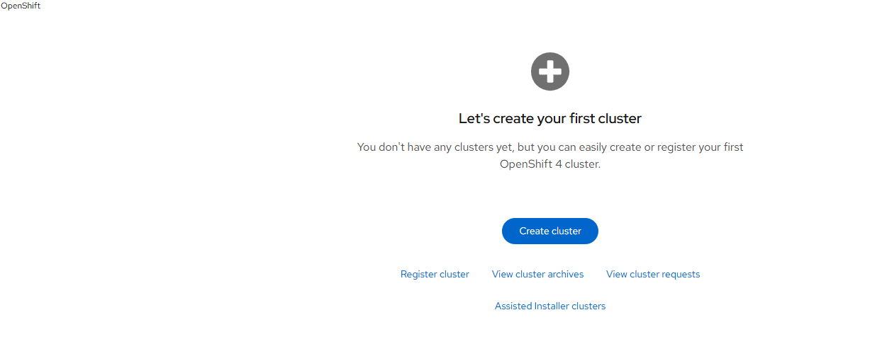
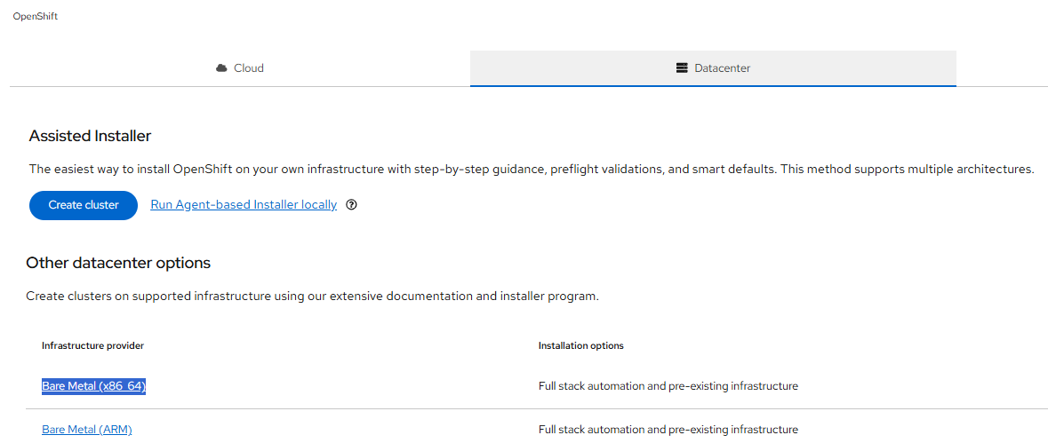

- In the next page select interactive
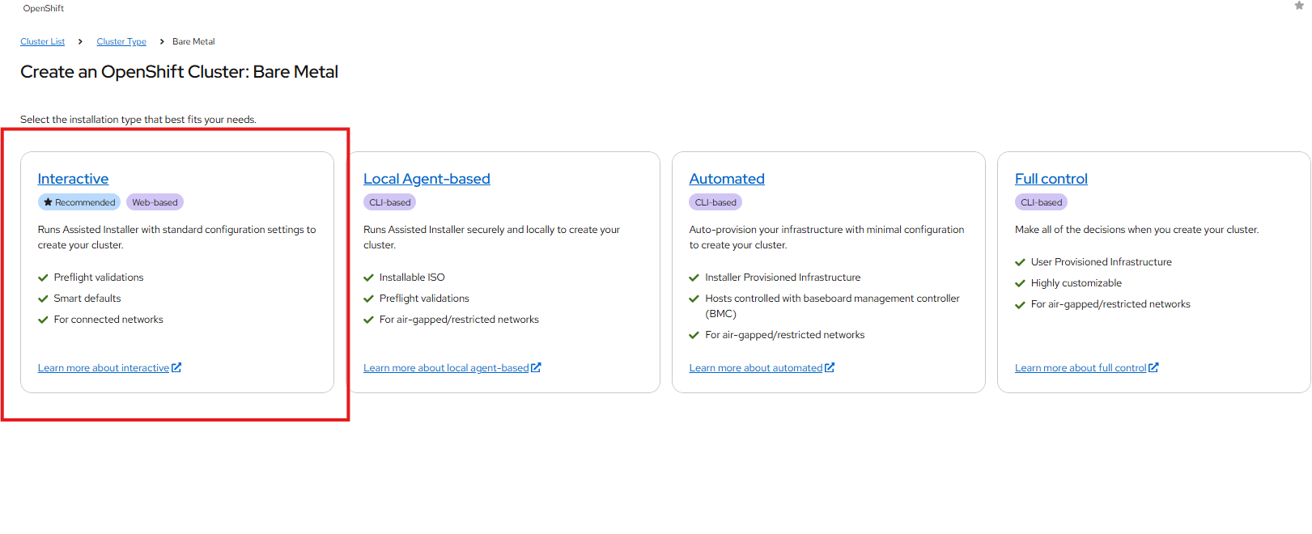

- In the next page fill in the details and click on next
- 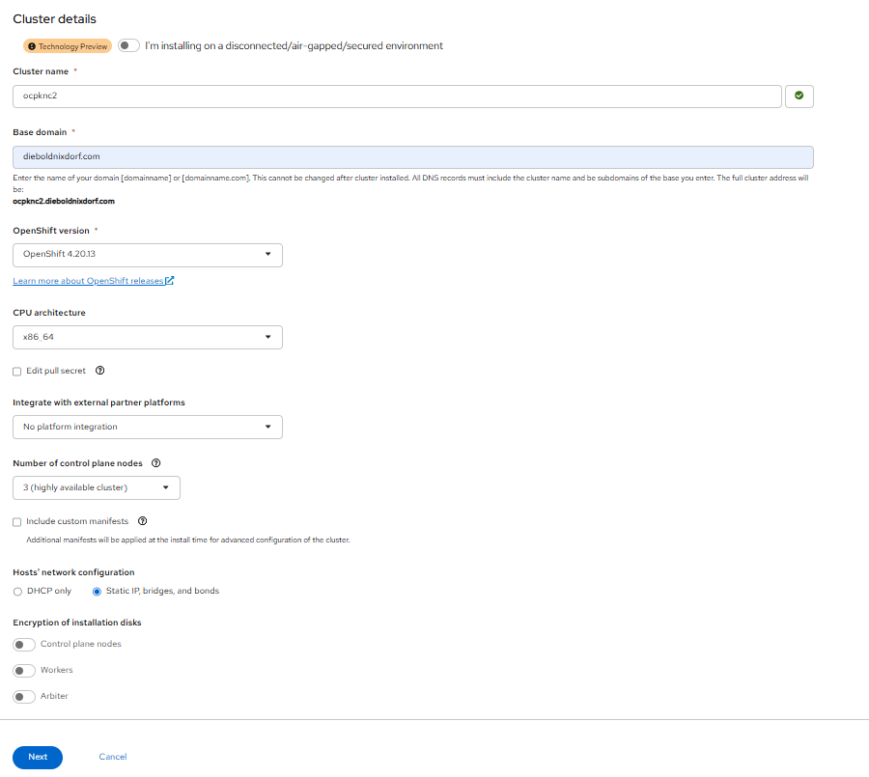

- In the next page fill in the details about DNS, subnet etc.
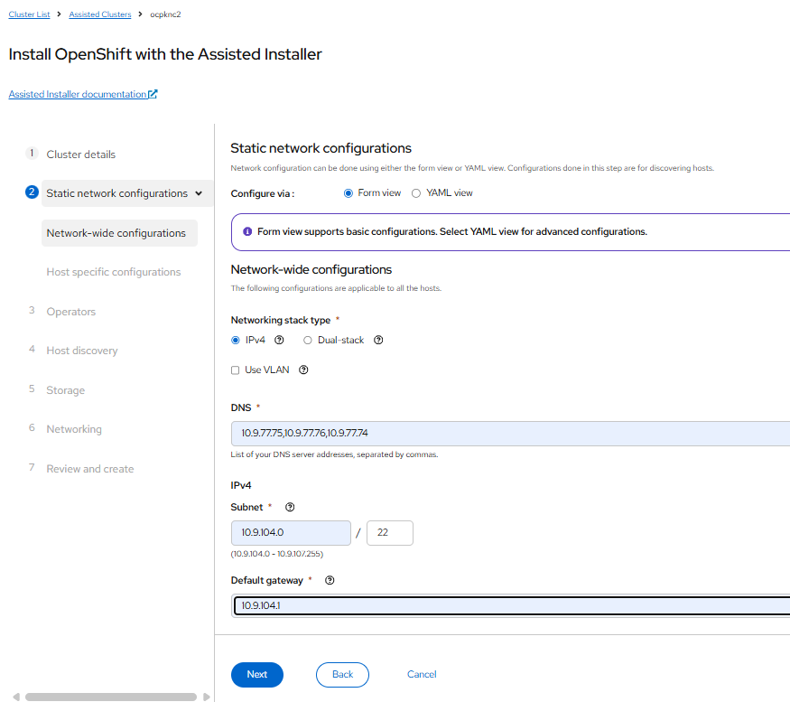

- In the next page fill in the details about bond and IPs and MAC addresses and click next.
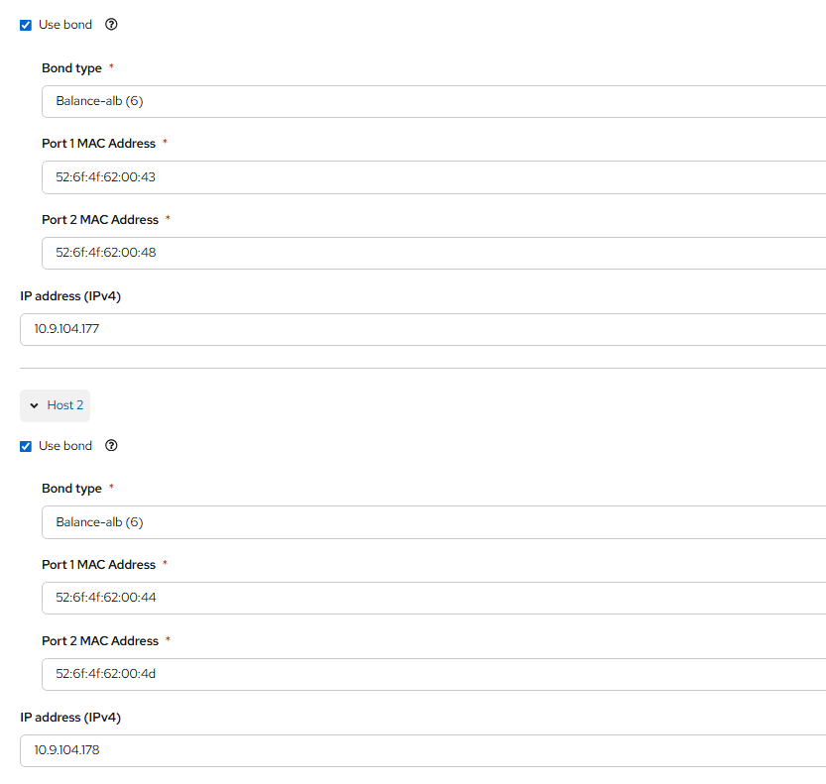

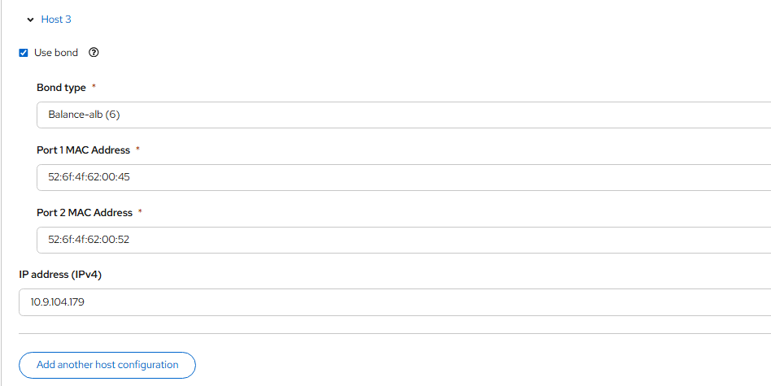

- In the next page, select operators to be installed(oprtional)
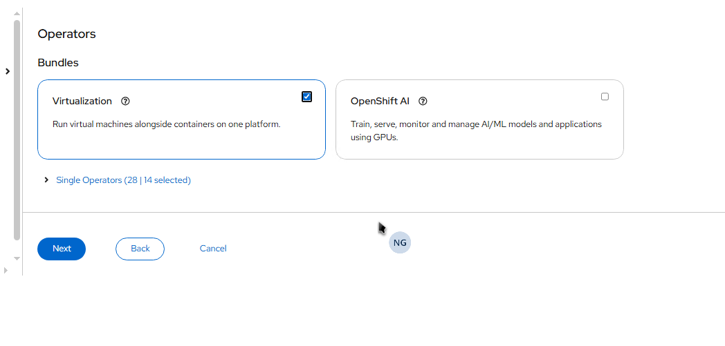
- In the next page click on add hosts, it will let you to download the ISO.
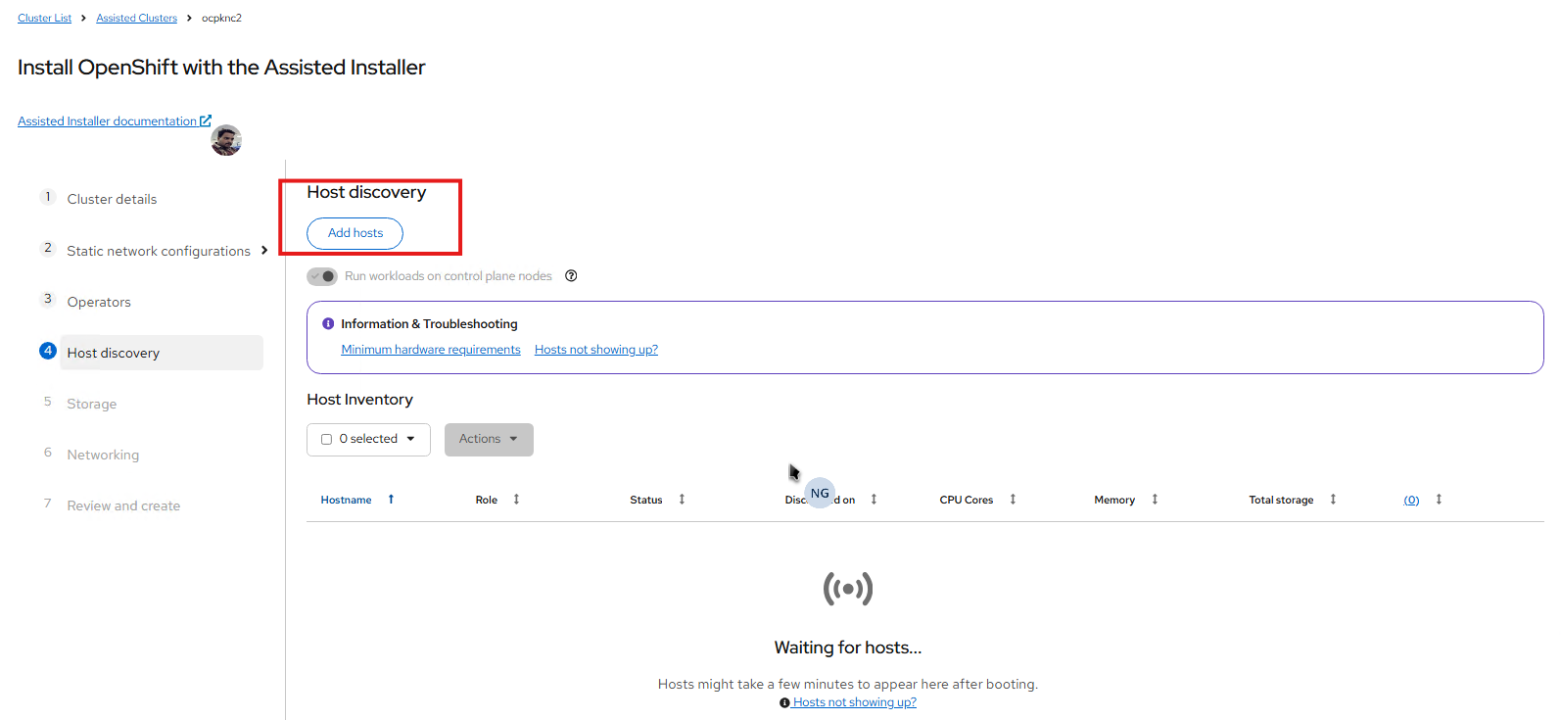

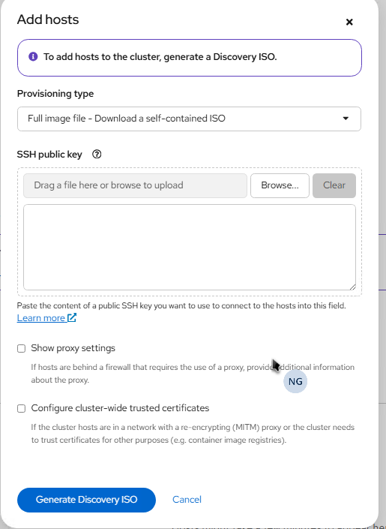
- Click on Generate ISO and then it will prompt us to download the ISO. Click on download ISO.
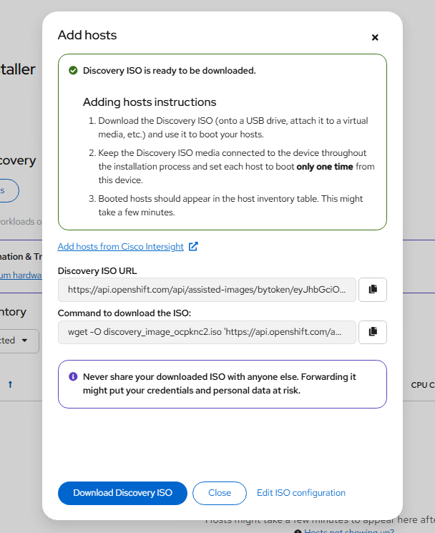

- The ISO will be downloaded, Once it is downloaded, please attach the ISO to console of the master nodes and boot them up.
- Once servers are booted, we will see 3 nodes getting discovered in console. Wait for them to appear in ready state. Once nodes are ready state, select them and click next.
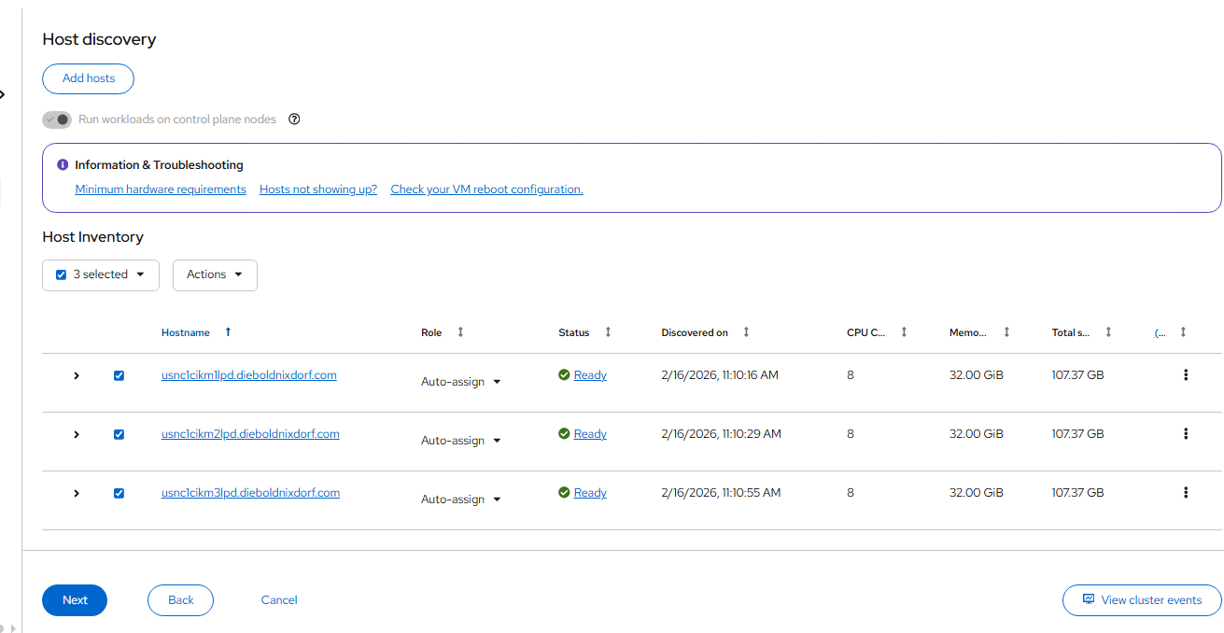

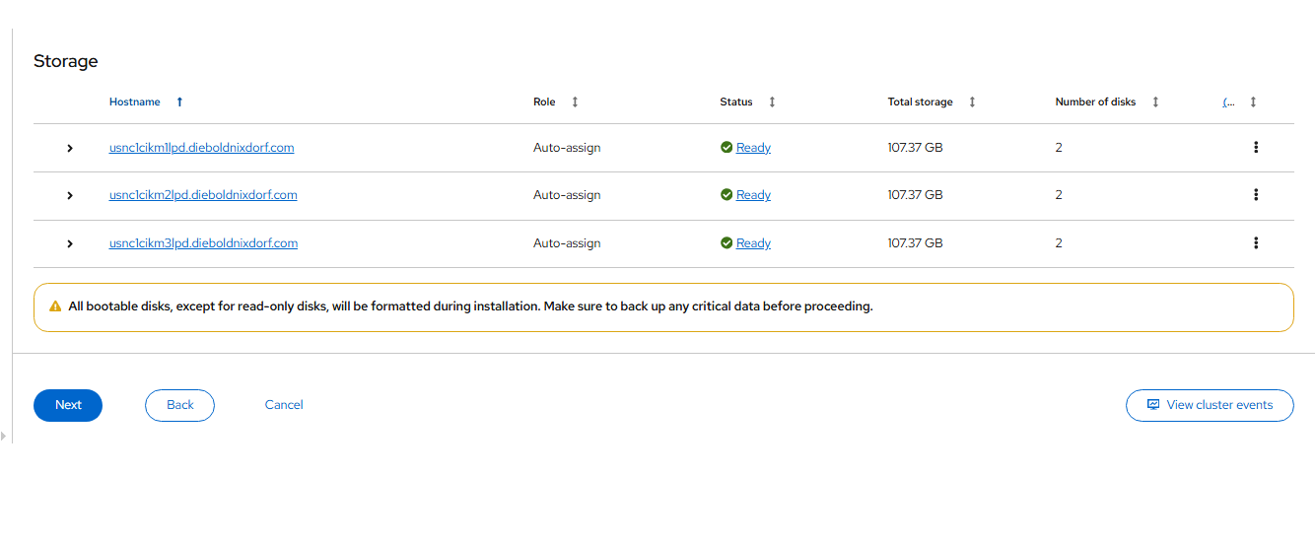
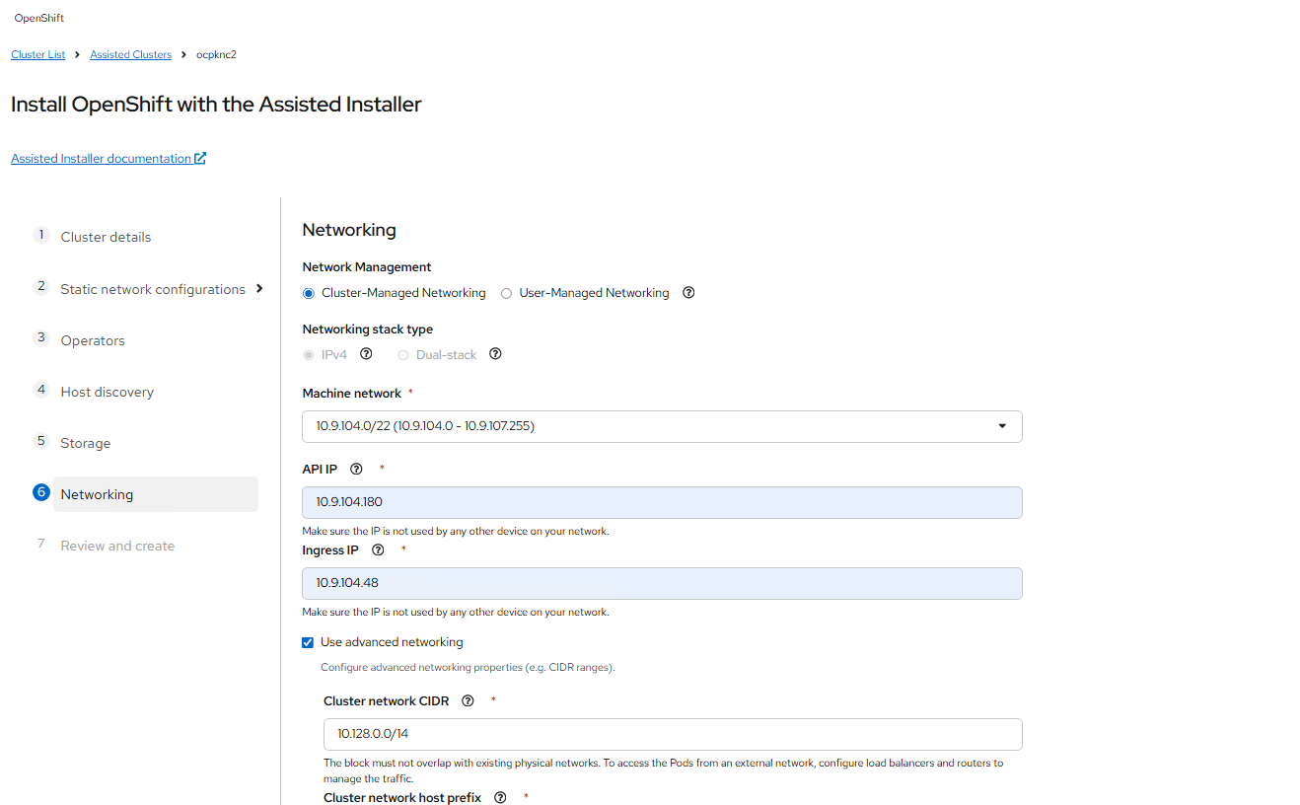

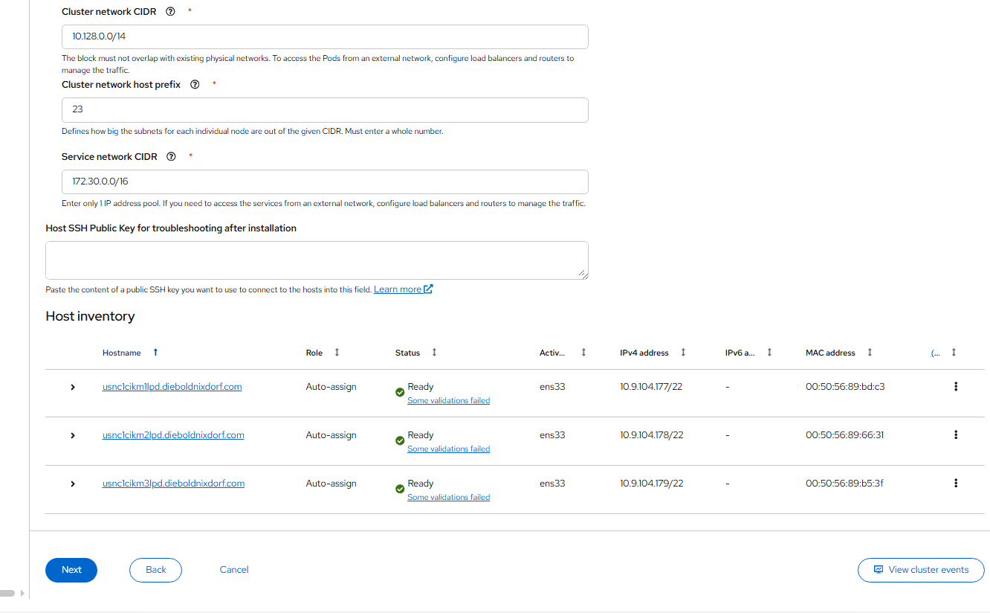

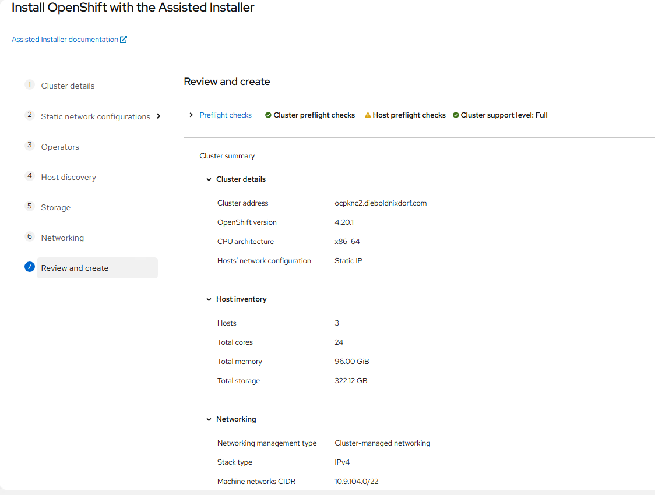

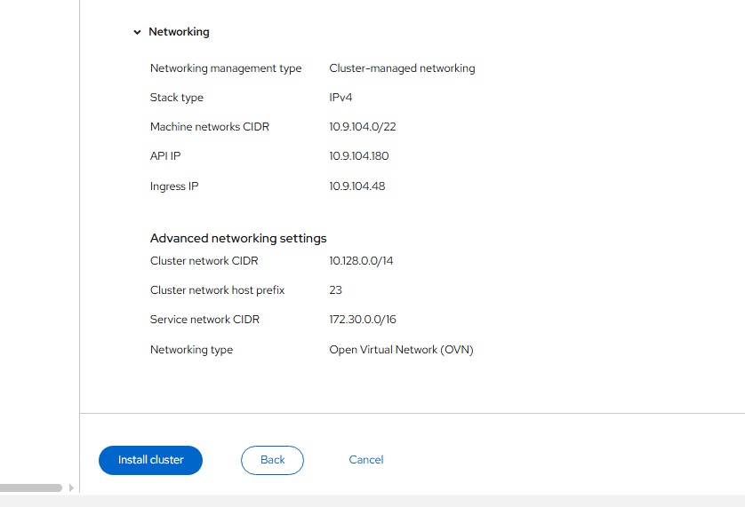

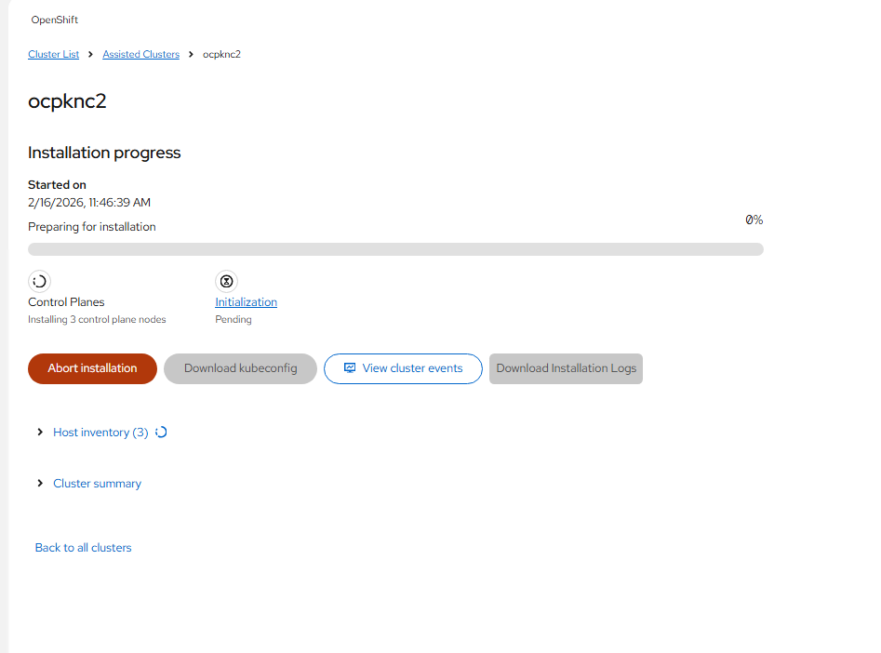
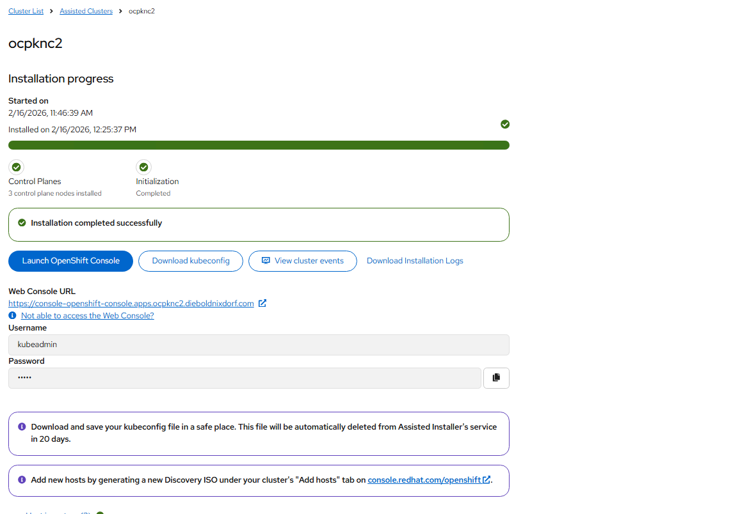
After this the cluster should be successful.

- Now start building the worker nodes. Using same steps.
- Under cluster manager, select the installed and clickon add hosts to build the worker nodes
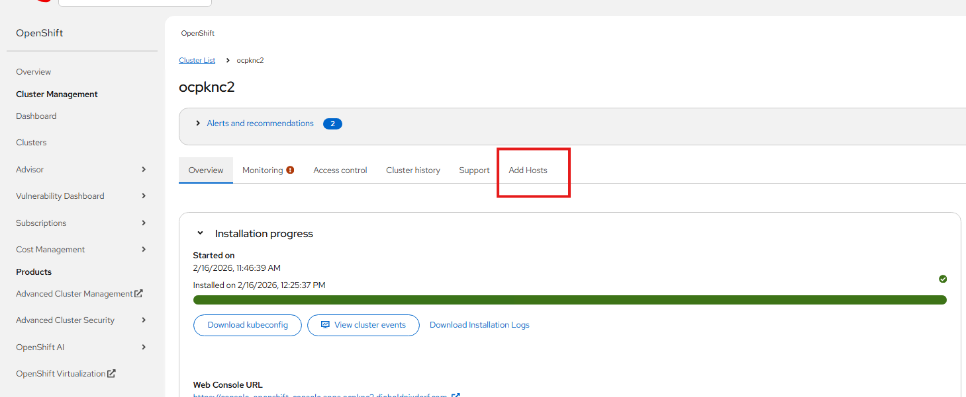

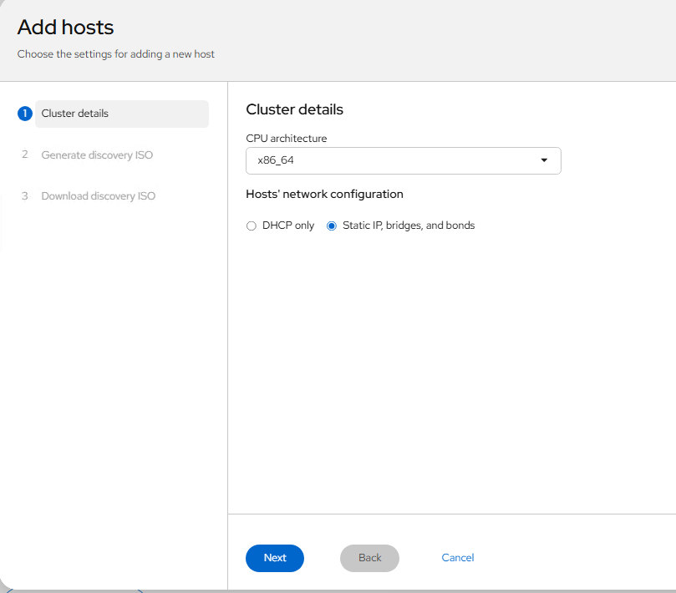

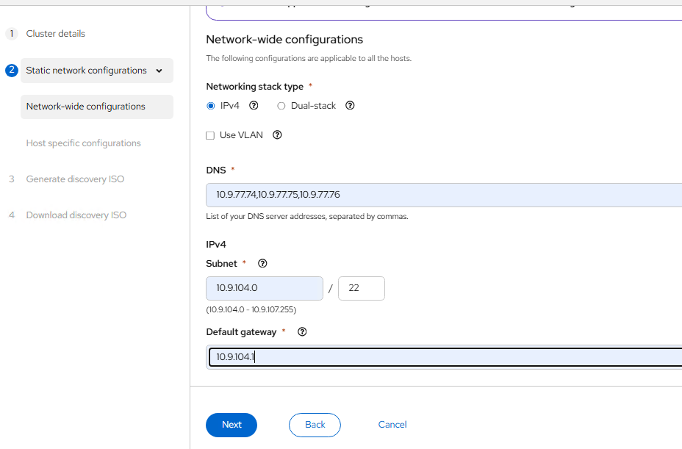

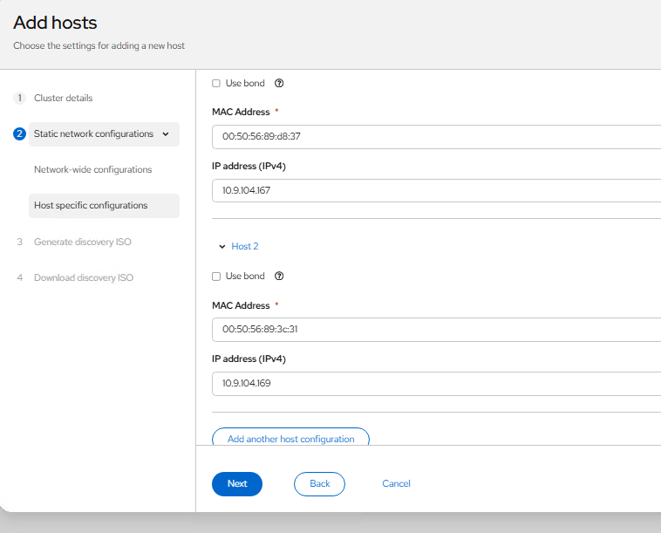

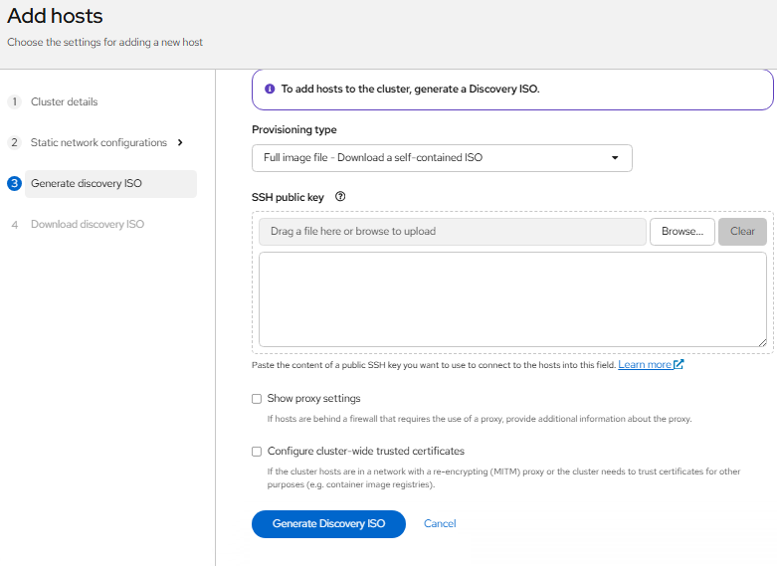

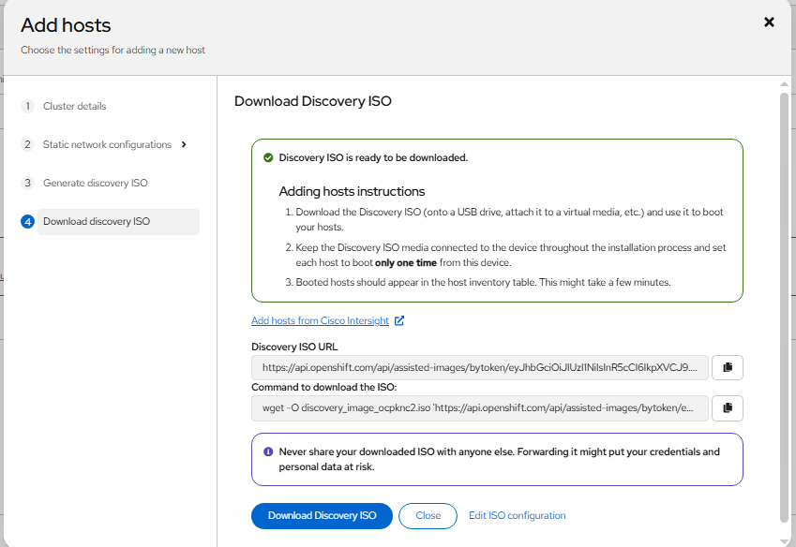

- Attach the ISO to worker nodes console and boot them. Once they are up,the worker node should get discovered and should be ready state. Once they are in ready click on install ready nodes.
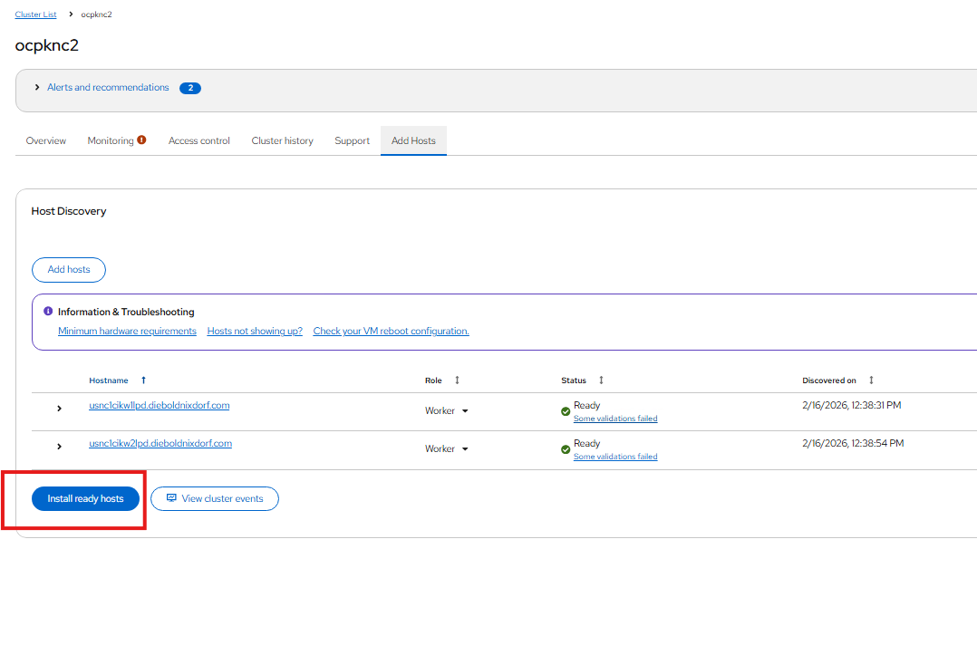

- Once installation is successful we should good to use the cluster.
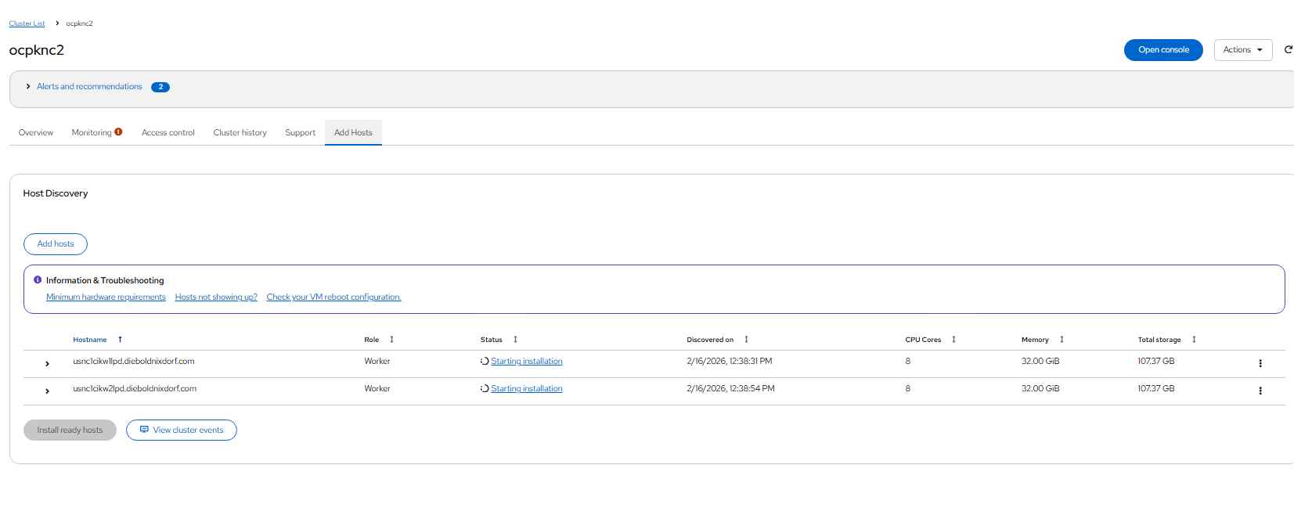
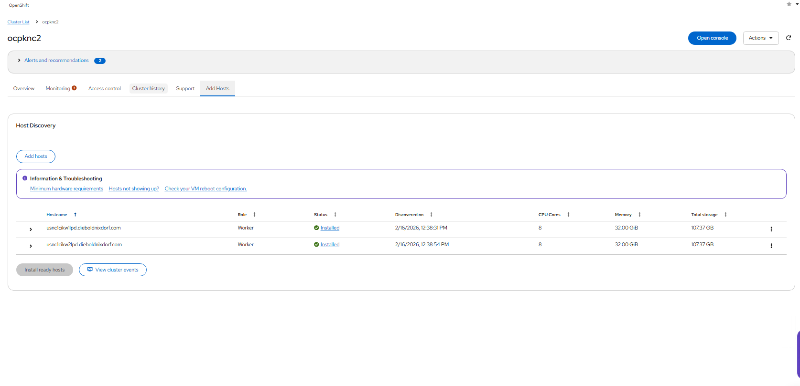
- Edit the scheduler yaml to make master nodes unschedulable.
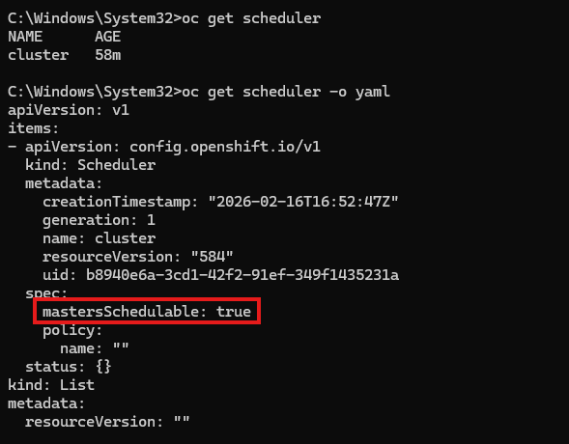
- Once this is done, the worker nodes should be populating automatically(once they approved from web gui).
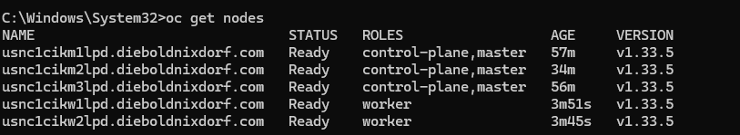

- Generate a certificate for ingress using *.apps.clustername.defaultdomain.com
- Change the certificate for ingress using below chain of commands
- oc create configmap custom-ca --from-file=ca-bundle.crt=path-to-chain\chain.crt -n openshift-config
- oc patch proxy/cluster --type=merge --patch='{"spec":{"trustedCA":{"name":"custom-ca"}}}'
- oc create secret tls ocpknc2-ocp --cert=path-to-hostnamecert\ocpknc2.crt --key=path-to-pricate-key\ocpknc2.key -n openshift-ingress
- oc patch ingresscontroller.operator default --type=merge -p '{"spec":{"defaultCertificate": {"name": "ocpknc2-ocp"}}}' -n openshift-ingress-operator

- Post this wait for sometime and check if all operators are online by checking oc get co.
- Post this get the DNS entry changed to F5 VIP for *.apps.clustername.defaultdomain.com, we should be able to login to console.

API VIP Failover:-
- Check which master holds the API VIP IP. For example below output is from Masternode3
- 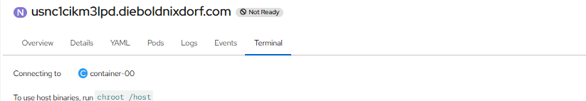
- Removed the masternode 3 from NW and API VIP is moved masternode2
